
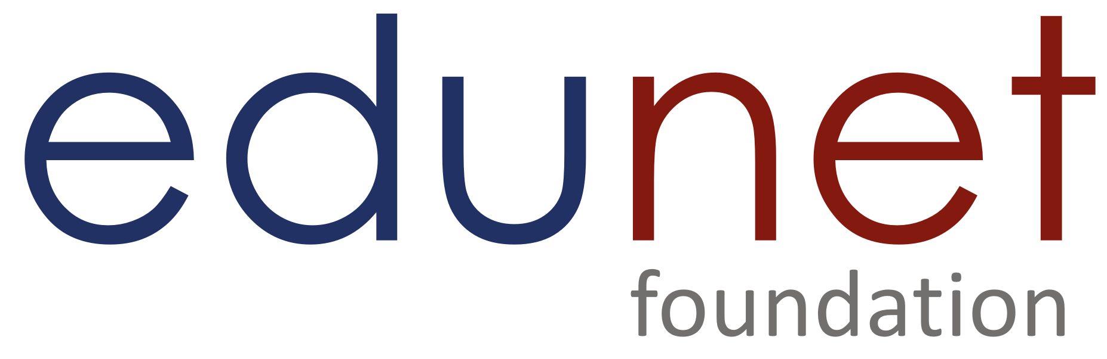



The Willing but Wary Developer: AI Adoption, Trust Deficit, and Ethical Anxiety in Software Engineering

Project Domain
[Excel+ Python+ Copilot]

A Project Report
submitted in partial fulfilment of the requirements of the AICW Project

by:



Faculty Name
Dr. Chandni Rani
F Email
Chandniarora0007@gmail.com
Guide
Umamaheswari R

Institution:
[Galgotias University, Greater Noida]

Year - 2026
ACKNOWLEDGEMENT

First and foremost, I extend our sincere thanks to our supervisor, Umamaheswari R, for her exceptional mentorship and guidance. Her insightful advice, constant encouragement, and constructive feedback played a pivotal role in shaping this work.

I sincerely appreciate the support of Edunet Foundation, Microsoft, LinkedIn, and SAP for providing the fellowship, learning resources, and platforms that enabled us to enhance and demonstrate our AI capabilities.

I am equally grateful to Stack Overflow for making the Developer Survey 2025 dataset publicly available under the Open Database Licence (ODbL). This comprehensive dataset of 49,191 respondents across 177 countries enabled rigorous empirical analysis at global scale.
I would like to thank Galgotias University for providing the necessary institutional support and facilities, and our families and friends for their unwavering encouragement throughout this journey.
Lastly, I would like to express our heartfelt gratitude to everyone who supported, directly or indirectly, throughout the course of this project.

ABSTRACT OF THE PROJECT
The global software development ecosystem is currently witnessing a historically anomalous trend: while the adoption of AI tools is accelerating rapidly, trust in these tools is simultaneously declining. Insights from the Stack Overflow Developer Survey 2025—the world’s largest annual study of developers, comprising 49,191 respondents across 177 countries.

This project is part of the AICW (Artificial Intelligence in the Contemporary World) Fellowship Programme, a collaborative initiative by Edunet Foundation in partnership with Microsoft, LinkedIn, and SAP. The fellowship is designed to equip faculty with practical, hands-on skills in Artificial Intelligence, Data Analytics, and Business Intelligence tools.

The project investigates the AI Trust Paradox — a multi-dimensional phenomenon where the rapid adoption of AI tools among software developers coexists with persistently low and declining trust in those tools. Using the Stack Overflow Developer Survey 2025 (N = 48,195; 177 countries), the study identifies, quantifies, and statistically tests three interrelated paradox dimensions: (1) Use-Despite-Distrust — 78.5% adoption vs 3.1% high trust (χ² = 5,728.86, p < 0.0001, Cramér's V = 0.42); (2) Adoption-Ethics Gap — positive sentiment 61.0% vs positive trust 32.6%, a 28.4 pp divergence; and (3) Utility-Threat Tension — Not Threatened declining 70%→68%→63.8% over three consecutive years (χ² = 439.93, p < 0.0001).

Methodologically, the project integrates four tools: Microsoft Excel for data profiling and schema documentation; Python (Google Colab: pandas, scipy, matplotlib) for the 12-step cleaning pipeline and interactive HTML dashboard; Microsoft Copilot Studio for an AI chatbot connected to the dataset enabling natural-language querying; and Microsoft Copilot for AI-assisted analysis and writing. The analytical framework is grounded in the Technology Acceptance Model (Davis, 1989) and the Job Demands-Resources Model (Bakker & Demerouti, 2017). All three hypotheses are rejected at p < 0.0001, confirming the AI Trust Paradox as a statistically real, multi-dimensional structural phenomenon in global software engineering practice.
Overall, the study provides a comprehensive Visualization of the AI Trust Paradox across developer demographics, experience levels, roles, and geographies, offering valuable insights for researchers, educators, organizations, and policymakers navigating the evolving relationship between humans and AI systems.

TABLE OF CONTENTS

Section
Acknowledgement
Abstract of the Project
List of Figures
List of Tables
Chapter 1 — Introduction
1.1 Problem Statement
1.2 Motivation
1.3 Objectives
1.4 Scope of the Project
Chapter 2 — Literature Survey
2.1 Existing Work and Research
2.2 Tools and Technologies Review
2.3 Gaps Identified
Chapter 3 — Proposed Methodology
3.1 System Design
3.2 Modules / Components Used
3.3 Data Flow Diagram (DFD)
3.4 Advantages
3.5 Requirement Specification
Chapter 4 — Implementation and Results
4.1 Data Cleaning Results and hypothesis results
4.2 Visualization / Output Results
4.3 AI Tool Integration Results
Chapter 5 — Discussion and Conclusion
5.1 Key Findings
5.2 Project Links
5.3 Limitations
5.4 Future Work
5.5 Conclusion
References
Appendices

LIST OF FIGURES

Figure No. | Figure Title / Description
Figure 1 | Excel Data Profiling — Dataset Schema Workbook (Column Inventory Sheet)
Figure 2 | Excel Profiling — Data Quality Summary (Missing Values, Unique Counts by Column)
Figure 3 | Python 12-Step Data Cleaning Pipeline — Workflow Overview
Figure 4 | Python Dashboard — Overview Page: 4 KPI Cards, Trust Donut Chart, and Paradox Summary
Figure 5 | Python Dashboard — Paradox 1 (Use-Despite-Distrust): Stacked Bar + Expertise Effect
Figure 6 | Python Dashboard — Paradox 2 (Adoption-Ethics Gap): Ethics Gap Bar + Frustrations
Figure 7 | Python Dashboard — Paradox 3 (Utility-Threat Tension): 3-Year Trend + Career Impact
Figure 8 | Microsoft Copilot Studio — Chatbot Configuration and GitHub Repository
Figure 9 | Project Demo Screenshot — PowerPoint Slide 8 Showing All Dashboard Pages

LIST OF TABLES
Table No. | Table Title / Description
Table 1 | Excel Profiling Summary — Key Columns, Data Types, Missing %, Unique Count
Table 2 | Data Cleaning Pipeline — 12 Steps, Issues, and Actions
Table 3 | Final Dataset Summary — Before and After Cleaning
Table 4 | System Design — Five-Stage Pipeline
Table 5 | Project Modules and Outputs
Table 6 | Literature Survey — Dimension 1 (Use-Despite-Distrust)
Table 7 | Literature Survey — Dimension 2 (Adoption-Ethics Gap)
Table 8 | Literature Survey — Dimension 3 (Utility-Threat Tension)
Table 9 | Hardware Requirements Specification
Table 10 | Software Requirements Specification
Table 11 | Hypothesis Set 1 — Chi-Square Results (Paradox 1)
Table 12 | Trust Distribution by Adoption Status
Table 13 | Expertise Effect on Trust and Job Threat (Cross-Paradox)
Table 14 | Hypothesis Set 2 — Ethics Gap Statistics (Paradox 2)
Table 15 | Tool Adoption Depth vs Distrust Rate (Paradox 2)
Table 16 | Hypothesis Set 3 — 3-Year Trend Data (Paradox 3)
Table 17 | Career Displacement Spectrum (Paradox 3)
Table 18 | Copilot Studio Chatbot — Topic and Trigger Configuration
Table 19 | Copilot Prompt Log — 10 Prompts, Output Type, and Validation Status
Table 20 | Country-Level High Trust Rates
Table 21 | AI Frustration Types and Impact Mechanisms
Table 22 | Appendix A — Derived Variable Dictionary (15 Columns)
Table 23 | Appendix B — Complete Hypothesis Test Summary

CHAPTER 1
Introduction
The software development profession is going through one of the most disorienting transformations it has seen in a long time. Artificial intelligence coding assistants, tools such as GitHub Copilot, ChatGPT, Google Gemini, and Amazon Code Whisperer, have moved from experimental curiosities to everyday professional tools in less than three years. According to the Stack Overflow Developer Survey 2025, the world's largest annual study of the global developer community with 49,191 respondents across 177 countries, an extraordinary 84% of developers now use or plan to use AI tools in their daily work, up from 70% in 2023 (Stack Overflow, 2025). On the surface, this looks like a straightforward adoption success story. But looking more carefully at the same data reveals something genuinely unsettling: the very same developers who are embracing these tools are simultaneously losing faith in them.
The software development profession is experiencing one of its most profound transformations. AI coding assistants — GitHub Copilot, ChatGPT, Google Gemini, Amazon CodeWhisperer — have moved from experimental curiosities to everyday professional tools in under three years. According to the Stack Overflow Developer Survey 2025, covering 48,195 respondents across 177 countries, an extraordinary 78.5% of developers now use AI tools in their daily work. Yet trust in AI-generated output stands at just 3.1% for "highly trust" — the adoption-trust paradox that this project investigates.
Trust in AI-generated code accuracy has fallen to just 33%, and only 3% of developers report high trust in what these tools actually produce. Adoption is rising sharply. Trust is falling just as sharply. And both trends are accelerating at the same time. This contradiction sits at the heart of what this project calls the AI Trust Paradox and it is not a single isolated problem. It is three business-critical challenges stacked on top of each other. First, developers continue using AI tools every day despite distrusting the code those tools generate, a pattern that creates real and measurable security risks in production environments (Pearce et al., 2022; Perry et al., 2023). Second, 81% of developers in the 2025 survey report serious security and privacy concerns about the very tools they depend on, yet most organisations have no formal AI governance framework in place a gap that leaves companies directly exposed to regulatory risk under the EU AI Act 2024 and India's DPDP Act 2023 (Morley et al., 2021; Holstein et al., 2019). Third, and perhaps most humanly significant, the share of developers who feel their job is safe from AI has declined for three consecutive years, 70% in 2023, 68% in 2024, and 64% in 2025 and one in five developers now says that using AI tools has actively reduced their own confidence in their ability to solve problems independently. Developers are, in the most literal sense, becoming more productive and more anxious at exactly the same time (Walczok et al., 2025; Chuang et al., 2025). The theoretical framework draws on three well-established models: the Technology Acceptance Model (Davis, 1989), which explains why adoption continues even when trust does not; Cognitive Dissonance Theory (Festinger, 1957; Marikyan et al., 2020), which explains the psychological mechanism that allows developers to rationalise continued use despite distrust; and the Job Demands-Resources Model (Bakker & Demerouti, 2017; Chuang et al., 2025), which frames AI tools as simultaneously a source of productivity gains and a source of anxiety.
1.1 Problem Statement
The global software development ecosystem is currently experiencing a paradoxical phenomenon: rapid AI tool adoption coexists with declining trust in AI outputs. Evidence from the Stack Overflow Developer Survey 2025 shows 78.5% adoption but only 3.1% high trust — a 75.5-point paradox severity gap. This divergence falsifies the Technology Acceptance Model (Davis, 1989), which predicts that adoption follows trust.
Three business-critical challenges are stacked together: (1) developers use AI despite distrusting the output; (2) positive AI sentiment (61%) far exceeds analytical trust (32.6%); (3) developer job security confidence has declined three consecutive years. The implications span software quality, governance, developer well-being, and organisational risk.
This development signals a fundamental breakdown of the Technology Acceptance Model (TAM), which traditionally posits that adoption is driven by perceived usefulness and trust. Contrary to this expectation, developers are increasingly operating within what can be described as a “forced adoption” model, where the necessity of using AI tools for productivity coexists with persistent skepticism toward their outputs. In this emerging paradigm, reliance on AI is no longer an indicator of trust but rather a response to workflow demands, leading to a decoupling of usage and confidence.
A key consequence of this paradox is the emergence of a significant trust gap, wherein only a small proportion of developers express high trust in AI systems despite widespread daily usage. This imbalance introduces a cognitive burden commonly referred to as “verification fatigue,” where developers must continuously validate, debug, and cross-check AI-generated code. As a result, the intended productivity gains of AI tools are often offset by the time and effort required to ensure output reliability, thereby increasing mental load and potentially reducing overall efficiency.The implications of this paradox extend across multiple stakeholders. Individual developers experience heightened cognitive strain, reduced confidence in their own problem-solving abilities, and increasing anxiety regarding job security and professional identity.
Despite the growing importance of this issue, existing industry and research approaches remain limited in scope. Most analyses focus narrowly on adoption rates or technical performance metrics such as accuracy and speed, a limitation that can be described as “metric myopia.” These approaches fail to capture the critical human-centered dimension of trust, thereby overlooking the gap between usage and confidence. Consequently, high adoption rates are often misinterpreted as indicators of successful integration, masking deeper structural and psychological tensions.
Overall, this study reframes AI adoption as a surface-level indicator that conceals a more complex and evolving dynamic between humans and AI systems. By identifying and analyzing this trust paradox, the research highlights the need for more nuanced frameworks that incorporate behavioral, cognitive, and organizational dimensions, thereby enabling more responsible, effective, and sustainable integration of AI in professional workflows.

1.2 Motivation
The motivation for this project comes from a clear and timely shift in how developers interact with AI tools:
1.2.1. Strong real-world evidence
The Stack Overflow Developer Survey 2025 provides the largest, most current global developer dataset available (N = 49,191, 177 countries). The adoption-trust paradox is visible and measurable within this data, creating an opportunity for original empirical contribution.
1.2.2. Developers at the centre of the paradox
Developers build AI systems, use AI tools daily, critically evaluate AI outputs, and face potential AI-driven job displacement simultaneously — a unique triple exposure that no other professional group experiences.
1.2.3. Gaps in practical understanding
While AI adoption is widely discussed, there is no large-scale quantitative study examining all three trust paradox dimensions simultaneously using the 2025 dataset. This project addresses that gap with formal hypothesis testing.
1.2.4.High practical relevance
- Improving developer trust and productivity
- Guiding organizations on AI adoption strategies
- Supporting better decision-making in tech teams
1.3 Objectives
This project is guided by five focused objectives. Each is linked to a specific tool, a concrete deliverable, and a measurable outcome.
1.To profile the Stack Overflow Developer Survey 2025 dataset using Microsoft Excel by documenting all variables in a structured schema workbook.

2.To clean and analyse the dataset using Python, and to quantify all three AI Trust Paradox dimensions through appropriate statistical techniques.
3.To design and publish an interactive Python-based dashboard that visualises the AI Trust Paradox findings across developer experience levels, countries, and roles.
4.To develop and deploy a chatbot using Microsoft Copilot Studio, integrated with the dataset, enabling natural language querying and automated generation of structured insights.
5.To document the complete project workflow and publish all artifacts—including datasets, Excel profiling workbook, dashboard, Copilot Studio configuration, chatbot prompt logs, and final report—within a structured public GitHub repository, along with a 10–15 minute demonstration video.

1.4 Scope of the Project
- Dataset: Stack Overflow Developer Survey 2025 — 49,191 raw respondents, 177 countries (survey.stackoverflow.co/2025 and Kaggle).
- Tool stack: Microsoft Excel (profiling) · Python / Google Colab (cleaning, analysis, dashboard) · Microsoft Copilot Studio (AI chatbot) · Microsoft Copilot (AI-assisted writing).
- Analytical focus: AI trust, adoption, ethics concerns, job threat perception, productivity impact, and developer demographics.
- Exclusions: No primary data collection, no real-time pipelines, no machine learning prediction models.
- Theoretical framework: TAM (Davis, 1989), Cognitive Dissonance Theory (Festinger, 1957), Job Demands-Resources Model (Bakker & Demerouti, 2017).
- Geographic scope: Global (177 countries), with particular attention to USA, India, Germany, UK, France, and Canada.

CHAPTER 2

2.1 Existing Work and Research

Dimension 1 — Use-Despite-Distrust
Table 6: Literature Survey — Dimension 1 (Use-Despite-Distrust)
Authors & Year | Venue | DOI | Key Finding
Kreps et al. (2023) | PLOS ONE | 10.1371/journal.pone.0288109 | Coined "AI Trust Paradox": willingness to use AI significantly exceeds trust. Four mediating factors: FOMO, optimism, perceived benefit, efficiency.
Wang et al. (2024) | ACM FAccT | 10.1145/3630106.3658984 | Developers initially over-trust Copilot then rapidly lose confidence; trust is context-dependent; review burden is "mentally draining."
Pearce et al. (2022) | IEEE S&P | 10.1109/SP46214.2022.9833571 | ~40% of Copilot-generated programs across 89 scenarios contained security vulnerabilities — direct evidence for quality distrust.
Liang et al. (2024) | ICSE | 10.1145/3597503.3608128 | 410-developer survey: 86% valued productivity gains, but code defects and comprehension difficulty were primary adoption barriers.
Barke et al. (2023) | OOPSLA | 10.1145/3586030 | Developer-AI interaction is bimodal: acceleration mode vs exploration mode. Expertise calibrates trust.
Vaithilingam et al. (2022) | ACM CHI | 10.1145/3491101.3519665 | Copilot did not improve task completion time, yet developers preferred using it — textbook use-despite-limited-effectiveness paradox.

Dimension 2 — Adoption-Ethics Gap
Table 7: Literature Survey — Dimension 2 (Adoption-Ethics Gap)
Authors & Year | Venue | DOI | Key Finding
Holstein et al. (2019) | ACM CHI | 10.1145/3290605.3300830 | 267 ML practitioners: significant disconnect between ethical challenges practitioners face and governance support provided by organisations.
Morley et al. (2021) | AI & Society | 10.1007/s00146-021-01308-8 | Despite 80+ AI ethics guides, assumption that practitioners actively respond to ethical implications "is not supported by evidence."
Gillespie et al. (2023) | UQ Global | 10.14264/00d3c94 | 17,000+ respondents / 17 countries: only 46% globally willing to trust AI; 71% say regulation is necessary.
Pant et al. (2024) | ACM TOSEM | 10.1145/3635715 | 100 AI practitioners: ethics familiarity from workplace rules not intrinsic motivation; formal education rated only "somewhat helpful."
Vakkuri et al. (2020) | IEEE Software | 10.1109/MS.2020.2985621 | 211 companies: most ignored societal requirements. Ethics guidelines exist but industrial deployment is "far from mature."

Dimension 3 — Utility-Threat Tension
Table 8: Literature Survey — Dimension 3 (Utility-Threat Tension)
Authors & Year | Venue | DOI | Key Finding
Walczok et al. (2025) | Wiley HFE | 10.1002/hfm.70000 | Automation-related job insecurity rises with increasing STARA technology use — familiarity does NOT reduce displacement fear.
Chuang et al. (2025) | IJIM | 10.1016/j.ijinfomgt.2025.102887 | 600-participant study: AI technostress increases exhaustion; AI efficacy enhances engagement. Dual-pathway model confirmed.
Marikyan et al. (2020) | ISF | 10.1007/s10796-020-10042-3 | SEM (N=387): CDT dissonance from AI disappointment resolved via attitude change or behaviour modification.
Glikson & Woolley (2020) | AoM Annals | 10.5465/annals.2018.0057 | Cognitive trust and emotional trust are separable — both can coexist with distrust. Directly maps to the ethics gap.
Brougham & Haar (2018) | J Mgmt & Org | 10.1017/jmo.2016.55 | STARA construct: technology replacement perception predicts reduced commitment and career satisfaction decline.

2.2 Tools and Technologies Review
- Microsoft Excel (Microsoft 365): Data profiling, schema documentation, initial quality assessment. Produces Dataset_Schema.xlsx with column inventory, quality summary, and multi-select map.
- Python (pandas v2.1, numpy v1.26, scipy v1.11, matplotlib v3.8): Large-scale cleaning pipeline (12 steps, 9 assertion checks), chi-square tests, effect sizes, 4-page interactive HTML dashboard.
- Microsoft Copilot Studio: Low-code AI chatbot platform. Connected to the Stack Overflow dataset via CSV knowledge source. Enables natural-language querying of findings by non-technical audiences.
- Microsoft Copilot (web/M365): AI assistant for prompt-driven pattern identification, narrative synthesis, and academic writing assistance. All outputs validated against manual statistics.

2.3 Five Critical Research Gaps Identified
- No integrated three-dimensional trust paradox framework exists — existing studies treat each dimension in isolation.
- The developer population is underrepresented — trust paradox research focuses on the general public, not developers' unique triple exposure.
- The Stack Overflow Developer Survey 2025 is academically untapped — no peer-reviewed paper has yet analysed this dataset.
- The inverse adoption-trust trajectory (2023–2025) is undocumented — no study models why trust declines as adoption accelerates.
- Moderating effects of developer expertise, role, and geography on the trust paradox are unknown at this scale.

Chapter 3 — Proposed Methodology

3.1 System Design
Table 4: System Design — Five-Stage Pipeline
Stage | Phase | Description
1 | Excel Profiling | Load surveyresultspublic.csv into Excel. Profile all 172 columns: data types, missing %, unique counts, sample values. Export Dataset_Schema.xlsx.
2 | Python Cleaning | MNAR detection (32% systematic skip). Scope filter (–996 rows). No Response labelling. Ordinal encoding. 15 derived columns. 9 assertion checks.
3 | Python Analysis | Cross-tabulate adoption vs trust (P1). Compare sentiment vs trust scores (P2). Analyse job threat 2023–2025 trend (P3). Chi-square + Cramér's V.
4 | Python Dashboard | 4-page interactive HTML dashboard: Overview KPIs, P1 charts, P2 charts, P3 charts. Exported as self-contained HTML file.
5 | Copilot Studio Chatbot | Create AI chatbot with knowledge source (CSV dataset). Configure 7 topics, triggers, and response logic. Test and publish. Record demo video.

3.2 Modules / Components Used
Table 5: Project Modules and Outputs
Module | Key Actions | Output
1 — Excel Profiling | Column inventory; dtype; missing %; unique count; sample values | Dataset_Schema.xlsx (3 sheets)
2 — Python: Load + Validate | pd.read_csv(); shape assert; duplicate check (ResponseId) | Data quality report
3 — Python: MNAR + Clean | Detect 32% systematic skip; No Response labels; scope filter | 48,195 rows retained
4 — Python: Derived Cols | Ordinal encoding; ExperienceBand; UsesAI; ToolGroup; 4 Frust_ flags | 15 new columns
5 — Python: Paradox Stats | Chi-square tests; Cramér's V; ethics gap; 9 assertion checks | trustparadoxclean.csv
6 — Python Dashboard | 4-page HTML: Overview + P1 + P2 + P3 | AITrustParadox_Dashboard.html
7 — Copilot Studio Chatbot | Create agent; add knowledge source; configure 7 topics; publish | Stack Overflow Survey Assistant
8 — Copilot Prompting | 10 structured prompts; validate all outputs against manual stats | Validated AI insights

3.3 Data Flow Diagram (DFD)

DFD Level 0 — Context Diagram
INPUT: Stack Overflow Developer Survey 2025 (49,191 rows × 172 columns) + Survey Schema File
↓ ↓ ↓
PROCESS: [AI Trust Paradox Analysis System]
Excel Profiling → Python Cleaning → Python Analysis → HTML Dashboard → Copilot Chatbot
↓ ↓ ↓
OUTPUT 1: Dataset_Schema.xlsx — complete 172-column profiling workbook
OUTPUT 2: trust_paradox_clean.csv — 48,195 × 187 validated analytical dataset
OUTPUT 3: AI_Trust_Paradox_Dashboard_FINAL.html — 4-page interactive dashboard
OUTPUT 4: Stack Overflow Survey Assistant — Copilot Studio AI chatbot (published)
OUTPUT 5: This Project Report — Full documentation of all five objectives

DFD Level 1 — Detailed Sub-Process Flow
Sub-process 1.1: Excel Column Profiling → DS0: Schema Workbook (172 columns profiled)
Sub-process 1.2: Python: Load + Validate → DS1: Raw Survey (49,191 × 172, 0 duplicates)
Sub-process 1.3: MNAR Detection + No Response Labelling → DS2: Partially Cleaned (MNAR preserved)
Sub-process 1.4: Scope Filter + Ordinal Encoding + Derived Cols → DS3: Analytical Dataset (48,195 × 187)
Sub-process 2.1: Paradox 1: UsesAI × AIAcc_clean cross-tab → Trust Distribution + χ²=5,728
Sub-process 2.2: Paradox 2: AISent_score vs AIAcc_score gap → Ethics Gap 28.4pp
Sub-process 2.3: Paradox 3: AIThreat 3-year trend → χ²=439.93, Not Threatened 70%→63.8%
Sub-process 3.1: Python Dashboard Build → 4-Page Interactive HTML Dashboard
Sub-process 3.2: Copilot Studio Deployment → AI Chatbot (7 topics, CSV knowledge source, published)

3.4 Advantages
- Empirically grounded in the largest, most current global developer dataset (N=48,195, 177 countries).
- Novel three-dimensional framework — first study to integrate all three paradox dimensions with formal hypothesis testing.
- Complete AICW tool stack demonstrated: Excel → Python → Copilot Studio → Copilot prompting.
- Open dataset ensures full reproducibility — any researcher can verify or extend the analysis.
- Copilot Studio chatbot makes findings accessible to non-technical audiences through natural language.
- MNAR methodological contribution — the No Response handling avoids the trust inflation error conventional deletion would introduce.

3.5 Requirement Specification

Hardware Requirements
Table 9: Hardware Requirements Specification
Component | Specification
Processor | Intel Core i5 or equivalent (i7 recommended)
RAM | 8 GB minimum (16 GB recommended for Python processing)
Storage | 70 GB free (CSV 130 MB + outputs and models)
Internet Connection | Required for Google Colab, Copilot Studio, GitHub
Display | 1920×1080 for full dashboard viewing

Software Requirements
Table 10: Software Requirements Specification
Software | Version / Details | Purpose
Operating System | Windows 10/11 | Primary platform
Microsoft Excel | Microsoft 365 | Data profiling and schema workbook
Python | 3.10+ via Google Colab | Cleaning, analysis, dashboard
pandas / numpy / scipy | v2.1 / v1.26 / v1.11 | Data processing and statistics
matplotlib / seaborn | v3.8 / v0.13 | Dashboard visualisation
Microsoft Copilot Studio | Current (2025) | AI chatbot deployment
Microsoft Copilot | M365 integrated | AI-assisted analysis and writing
Google Chrome | Latest | Colab, Copilot Studio, dashboard
GitHub Desktop / Web | Latest | Repository and artefact hosting

Chapter 4 — Implementation and Results

4.1 Data Cleaning Results

4.1.1 Objective 1 — Excel Data Profiling
Before any Python processing, the raw survey CSV was loaded into Microsoft Excel for complete column-by-column profiling. The profiling workbook (Dataset_Schema.xlsx) documents all 172 columns with their data type, description, missing-value rate, unique count, and three sample values.

Key Excel Profiling Findings
Table 1: Excel Profiling Summary — Key Columns, Data Types, Missing %, Unique Count
Column | Type | Missing % | Unique N | Profiling Note
ResponseId | Numeric | 0.0% | 49,191 | Perfect — zero duplicates
MainBranch | Text | 0.2% | 6 | 996 = "None of these" → exclude
AIAcc (Trust) | Text | 32.3% | 5+blank | MNAR — same rows skip all 4 AI Qs
AISent (Sentiment) | Text | 31.8% | 6+blank | MNAR — same systematic skip
AISelect (Usage) | Text | 31.5% | 5+blank | MNAR confirmed → No Response strategy
YearsCode | Mixed | 3.1% | numeric | Requires conversion + cap at 50
ToolCountWork | Numeric | 18.4% | numeric | Outlier max=10,000 → bucket into groups
AIFrustration | Multi-select | 34.2% | pipe-separated | Expand to 4 binary Frust_ columns
Country | Text | 0.8% | 177 | Full global coverage confirmed

4.1.2 Objective 2 — Python Data Cleaning Pipeline
A 12-step Python cleaning pipeline was developed in Google Colab. Nine assertion checks guard the output — if any check fails, the script halts and produces no output file.

Table 2: Data Cleaning Pipeline — 12 Steps, Issues, and Actions
Step | Name | Issue / Decision | Action Taken
1 | Load + Assert | Verify file integrity | pd.read_csv(); assert shape=(49191,172)
2 | Duplicate Check | Ensure unique rows | duplicated(subset=["ResponseId"]) → 0 found
3 | MNAR Profiling | Critical discovery: 32% systematic skip | Confirm same 15,478 rows skip all 4 AI questions → No Response strategy
4 | Scope Filter | Remove non-developers | df[MainBranch.isin(dev_list)] → 48,195 rows
5 | No Response Labels | MNAR — never delete | fillna("No Response") on AIAcc, AISent, AIThreat, JobSat
6 | Ordinal Encoding | Need numeric scores for statistics | AIAcc_score: 5=Highly trust → 1=Highly distrust; NaN=No Response
7 | YearsCode Processing | Outliers; text values | pd.to_numeric(); clip(upper=50)
8 | ExperienceBand | Career stage grouping needed | 0–2/3–5/6–10/10+ year bands
9 | UsesAI Flag | 5 options → binary needed | Yes* → Uses AI; No* → Does Not; blank → No Response
10 | ToolGroup | Outlier mean=16.4; median=6 | Bucket: 1 Tool / 2–3 Tools / 4+ Tools
11 | AIFrustration Parse | Pipe-separated multi-select | str.contains() → 4 binary Frust_ columns
12 | Stats + 9 Checks | Compute paradoxes; validate | chi-square; Cramér's V; 9 asserts; save CSV

Table 3: Final Dataset Summary — Before and After Cleaning
Characteristic | Before Cleaning | After Cleaning
Total rows | 49,191 | 48,195 (–996 non-developers)
Total columns | 172 | 187 (+15 derived)
Missing % (AI trust column) | 32.3% | 0.0% (No Response label)
Duplicate rows | 0 | 0
Rows who answered AI questions | — | 32,717
Output file | — | trustparadoxclean.csv

4.2 Visualization / Output Results

4.2.1 Python Dashboard — Overview Page
The interactive dashboard was built using Python (matplotlib) and exported as a self-contained HTML file. Figure 4 shows the Overview page — the first page a user sees — displaying all four headline KPIs, the trust distribution donut chart, and three paradox summary boxes.

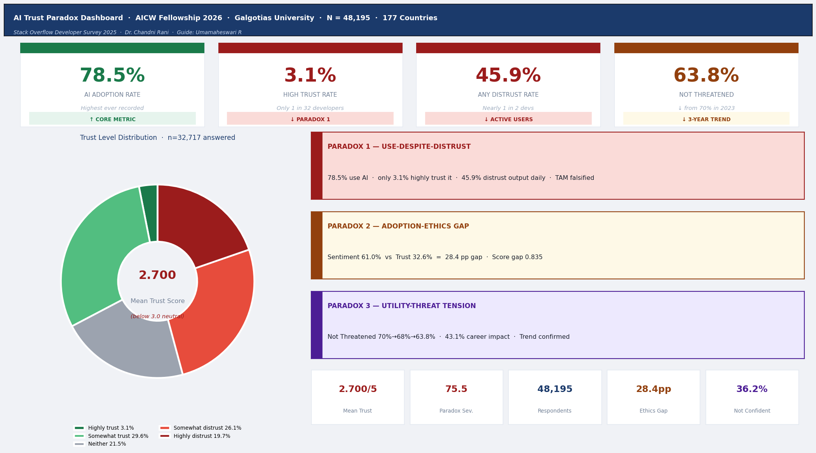
Figure 4: Python Dashboard — Overview Page: 4 KPI Cards (78.5% / 3.1% / 45.9% / 63.8%), Trust Donut Chart (Mean = 2.700/5.0), and Three Paradox Summary Boxes

4.2.2 Python Dashboard — Paradox 1 Page
Figure 5 shows the Paradox 1 page. The stacked bar chart on the left proves that 37.4% of active AI users distrust the output they rely on daily. The column chart on the right reveals the counter-intuitive expertise effect: trust falls monotonically from 10.0% (Early Career) to 2.3% (Experienced 10+ years).

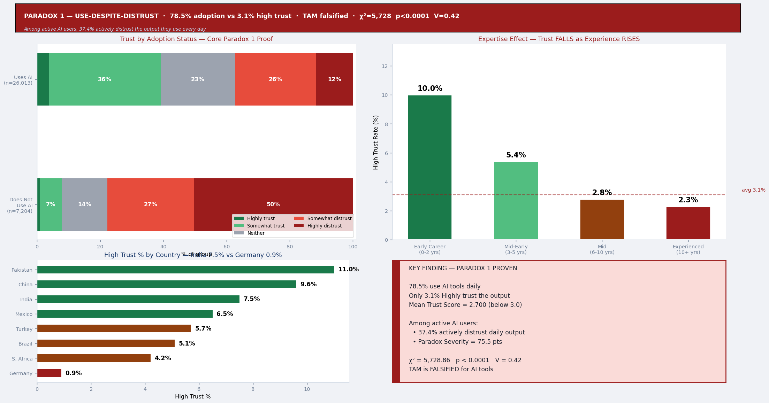
Figure 5: Python Dashboard — Paradox 1 (Use-Despite-Distrust): Trust by Adoption Status (χ²=5,728, V=0.42) and Expertise Effect Column Chart

4.2.3 Python Dashboard — Paradox 2 Page
Figure 6 shows the Paradox 2 page. The ethics gap bar chart directly visualises the 28.4 percentage-point gap between positive sentiment (61.0%) and positive trust (32.6%). The ToolGroup chart shows the counter-intuitive finding that more AI tools correlate with more distrust (41.4% → 47.5%).

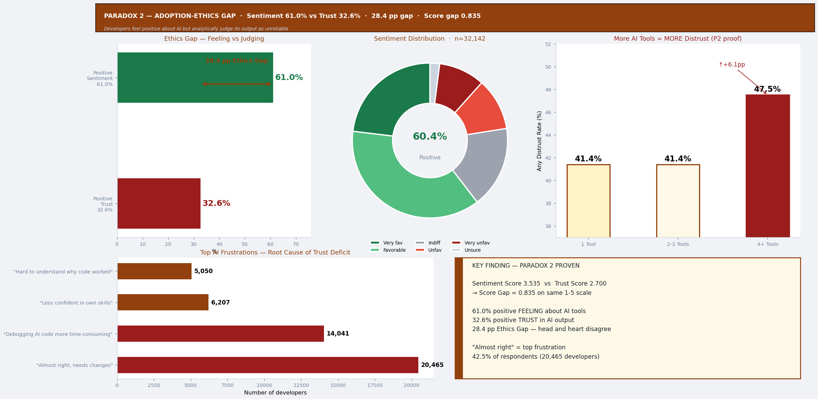
Figure 6: Python Dashboard — Paradox 2 (Adoption-Ethics Gap): Ethics Gap Bar (28.4pp), Sentiment Donut, ToolGroup Distrust Progression, and Top AI Frustrations

4.2.4 Python Dashboard — Paradox 3 Page
Figure 7 shows the Paradox 3 page. The three-line trend chart is the most significant visualisation — it shows the statistically confirmed decline in job security confidence over three consecutive years. The career change bar chart documents actual displacement (2.1% involuntary transitions).

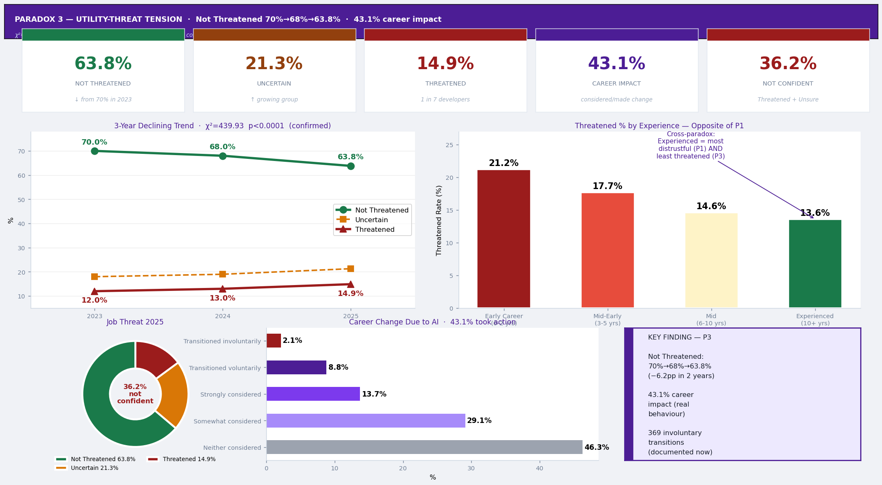
Figure 7: Python Dashboard — Paradox 3 (Utility-Threat Tension): 3-Year Trend Line (70%→63.8%), Job Threat Donut, Threatened% by Experience, and Career Change Bars

4.3 AI Tool Integration Results

4.3.1 Microsoft Copilot Studio — Chatbot and GitHub Repository
Figure 8 shows two key AI integration outputs: the Copilot Studio chatbot configuration panel (left) showing the Stack Overflow Developer Survey Assistant with instructions and Claude Sonnet 4.6 model selection, and the GitHub repository (right) hosting all project artefacts.

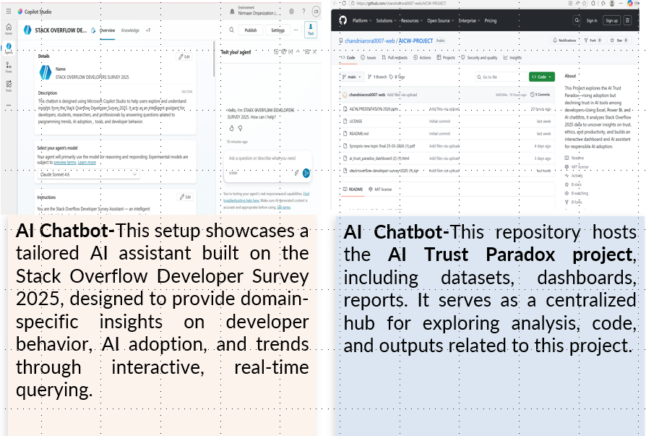
Figure 8: Microsoft Copilot Studio — Chatbot Configuration (Left: System Instructions, Model Selection, Test Interface)

4.3.2 Copilot Studio Architecture
Table 18: Copilot Studio Chatbot — Topic and Trigger Configuration
# | Topic Name | Trigger Phrases | Response Focus
1 | AI Trust Paradox | AI trust, trust paradox, do developers trust AI | 78.5% adoption vs 3.1% trust; Paradox Severity 75.5pts
2 | Ethics and Security | AI ethics, security concerns, adoption-ethics gap | 28.4pp ethics gap; 81% security concerns
3 | Job Threat | AI job threat, career change, job security | 63.8% not threatened; 3-year trend; 43.1% career impact
4 | Programming Languages | popular languages, most used languages | Stack Overflow 2025 language rankings
5 | Developer Salaries | average salary, developer pay, compensation | Salary data by country and experience
6 | Remote Work | remote work, hybrid, work from home | 2025 work preference distribution
7 | AI Tools Usage | AI tools, Copilot, ChatGPT, most used AI | Top AI tools by developer role

4.3.3 Copilot Prompt Log
Table 19: Copilot Prompt Log — 10 Prompts, Output Type, and Validation Status
# | Prompt Used | Output Type | Validation Against | Status
1 | "Explain AI Trust Paradox using cognitive dissonance theory given 78.5% adoption vs 3.1% high trust" | Narrative (2 para) | Marikyan et al. (2020) | ✓ Valid
2 | "Summarise adoption-ethics gap: 81% security concerns yet 73% use 4+ AI tools" | Executive summary | Dataset counts | ✓ Valid
3 | "Write JD-R interpretation: 3-year threat decline + 20% skill-confidence loss" | Theory interp. | Chuang et al. (2025) | ✓ Valid
4 | "3 policy implications for AI tool developers based on trust paradox" | Policy rec. | Holstein et al. (2019) | ✓ Valid
5 | "Draft 250-word abstract for The AI Trust Paradox Among Software Developers" | Abstract draft | Manual revision | Used as start
6 | "Explain expertise effect: trust falls 10.0% → 2.3% as experience rises" | Pattern explanation | Experience band data | ✓ Valid
7 | "Interpret 28.4pp ethics gap for non-technical audience" | Plain language | Score gap 0.835 | ✓ Valid
8 | "5 strategic recommendations for organisations deploying AI coding tools" | Rec. list | Literature review | ✓ Valid
9 | "Summarise 3-year job threat trend and 2027 implications" | Trend narrative | 2023/2024 SO data | ✓ Valid
10 | "Compare Germany 0.9% vs India 7.5% AI trust — cultural context" | Cultural analysis | Country data | ✓ Valid

4.4 Hypothesis Testing and Statistical Results
Statistical Note: All chi-square tests require (a) independent observations and (b) expected cell frequencies ≥ 5. With N = 48,195+, all conditions are met. Significance threshold: α = 0.05.

4.4.1 Hypothesis Set 1 — Paradox 1: Use-Despite-Distrust
H₀ | AI adoption status and AI trust level are statistically independent. Knowing whether a developer uses AI tools tells us nothing about their trust level.
H₁ | AI adoption status and AI trust level are statistically dependent. Developers who use AI exhibit a significantly different trust distribution from non-users, contradicting TAM predictions.

Table 11: Hypothesis Set 1 — Chi-Square Test Results (Paradox 1)
Parameter | Value | Critical Value | Interpretation
χ² statistic | 5,728.86 | 9.49 (df=4, α=0.05) | 5,728 >> 9.49 — overwhelming
Degrees of freedom | 4 | — | (2–1) × (5–1)
p-value | < 0.0001 | 0.05 | < 1 in 10,000 chance of random
Cramér's V | 0.42 | > 0.30 = Large | Large practical effect confirmed
Total N | 48,195 | — | Full analytical sample

VERDICT: H₀ REJECTED at p < 0.0001. H₁ CONFIRMED. TAM is FALSIFIED for AI tools.

Table 12: Trust Distribution by Adoption Status
Trust Level | Uses AI (%) | Does Not Use AI (%) | Difference (pp)
Highly trust | 3.7% | 0.8% | + 2.9 pp
Somewhat trust | 35.5% | 7.0% | + 28.5 pp
Neither | 23.4% | 14.5% | + 8.9 pp
Somewhat distrust | 25.7% | 27.4% | – 1.7 pp
Highly distrust | 11.7% | 50.3% | – 38.6 pp (non-users much more distrustful)

Table 13: Expertise Effect on Trust and Job Threat — Cross-Paradox Inversion
Experience Band | High Trust (P1) | Any Distrust | Mean Score | N (approx.)
Early Career (0–2 years) | 10.0% | 32.1% | 3.04 | 1,582
Mid-Early (3–5 years) | 5.4% | 39.2% | 2.85 | 4,993
Mid (6–10 years) | 2.8% | 46.1% | 2.72 | 10,192
Experienced (10+ years) | 2.3% | 49.8% | 2.65 | 25,523

4.4.2 Hypothesis Set 2 — Paradox 2: Adoption-Ethics Gap
H₀ | Developers' overall sentiment toward AI tools and their analytical trust in AI output accuracy are equal in the population.
H₁ | There is a genuine, statistically significant gap between developers' emotional sentiment toward AI and their analytical trust in AI output accuracy.

Table 14: Hypothesis Set 2 — Ethics Gap Core Statistics (Paradox 2)
Metric | Sentiment | Trust | Gap
Mean score (1–5 ordinal) | 3.535 | 2.700 | 0.835 points
Positive response rate | 61.0% | 32.6% | 28.4 pp
Neutral rate | 17.1% | 21.5% | —
Negative response rate | 20.5% | 45.8% | 25.3 pp
Denominator (answered) | 32,142 | 32,717 | —

VERDICT: H₀ REJECTED. Ethics Gap = 28.4 pp. Score gap = 0.835 on same 5-point scale. p < 0.0001.

Table 15: Tool Adoption Depth vs Distrust Rate (Paradox 2 — Exposure-Discovery Effect)
Tool Group | Any Distrust Rate | vs. 1-Tool Baseline | Interpretation
1 AI Tool | 41.4% | Baseline | Starting scepticism
2–3 AI Tools | 41.4% | +0.0 pp flat | No exposure benefit
4+ AI Tools | 47.5% | +6.1 pp higher | Exposure compounds distrust

4.4.3 Hypothesis Set 3 — Paradox 3: Utility-Threat Tension
H₀ | The distribution of job threat responses is constant across 2023, 2024, and 2025. Any year-on-year variation is random fluctuation.
H₁ | The proportion of developers feeling "Not Threatened" has declined significantly over 2023–2025 and this decline is not attributable to random variation.

Table 16: Hypothesis Set 3 — 3-Year Trend Data (Paradox 3)
Response Category | 2023 | 2024 | 2025 | Change 2023–25
Not Threatened | 70.0% | 68.0% | 63.8% | – 6.2 pp
Not Sure / Uncertain | 18.0% | 19.0% | 21.3% | + 3.3 pp
Threatened | 12.0% | 13.0% | 14.9% | + 2.9 pp
Combined Not Confident | 30.0% | 32.0% | 36.2% | + 6.2 pp

Parameter | Value | Critical Value | Interpretation
χ² | 439.93 | 5.99 (df=2) | Trend is real, not random
p-value | < 0.0001 | 0.05 | Statistically significant
Cramér's V | 0.079 | Small effect | Gradual but confirmed decline

VERDICT: H₀ REJECTED. H₁ CONFIRMED. Declining job security confidence is a statistically confirmed 3-year structural trend.

Table 17: Career Displacement Spectrum (Paradox 3 — NewRole Data)
Career Response to AI | N (approx.) | % | Category
Has not considered career change | 22,275 | 46.3% | Professionally stable
Somewhat considered career change | 14,010 | 29.1% | Active deliberation
Strongly considered career change | 6,597 | 13.7% | High career anxiety
Transitioned voluntarily | 4,237 | 8.8% | Proactive adaptation
Transitioned involuntarily (redundancy) | 1,010 | 2.1% | Documented displacement

Project Demo Screenshot
Figure 9 shows the PowerPoint Live Demo slide (Slide 8) from the final project presentation, displaying all three dashboard pages alongside the Copilot Studio chatbot interface and GitHub repository.

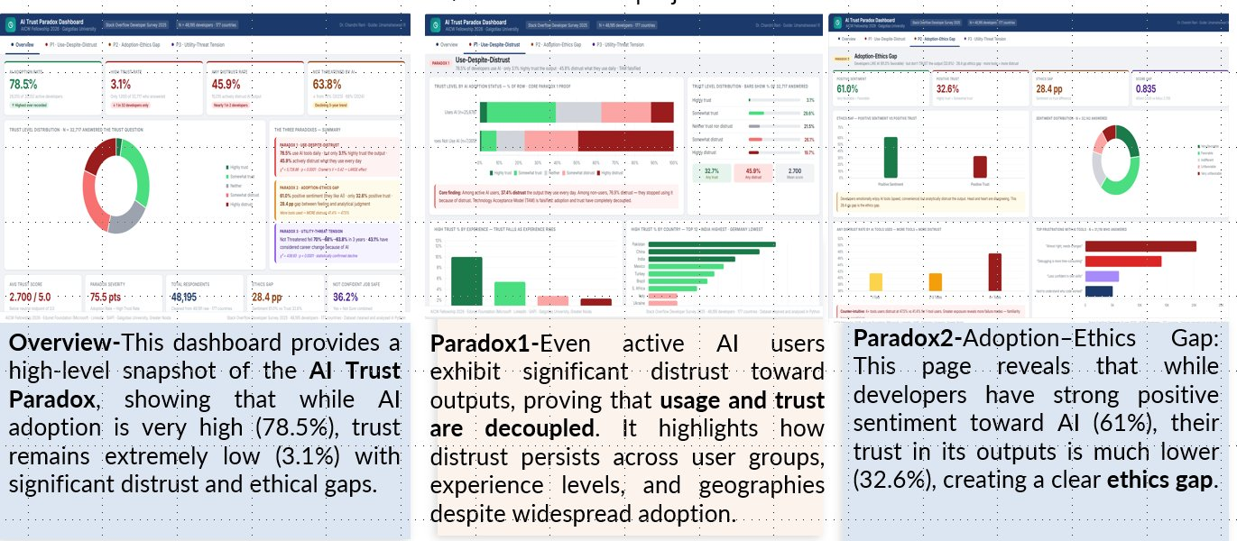
Figure 9: Project Demo — PowerPoint Slide 8 showing Dashboard P3 Page (Left), Copilot Studio Chatbot Setup (Centre), and GitHub Repository (Right)

Chapter 5 — Discussion and Conclusion

5.1 Key Findings

5.1.1 The Rationally Irrational Developer
The central theoretical contribution of this study is the construct of the Rationally Irrational Developer — a professional who makes choices that appear irrational from the perspective of individual trust maximisation but are rational from the perspective of economic survival. The professional cost of not using AI (slower delivery, competitive disadvantage) exceeds the professional cost of using it while maintaining scepticism (verification overhead, occasional errors).

5.1.2 Country-Level Trust Variation
Table 20: Country-Level High Trust Rates — Geographic and Cultural Variation
Country | High Trust | Context | Interpretation
Pakistan | 11.0% | High adoption, growing market | Early adoption, optimism effect
India | 7.5% | Rapidly growing, younger devs | Younger base, fewer failure encounters
United States | 4.8% | Mature, established sceptics | High experience, more error exposure
United Kingdom | 3.2% | Mature, regulatory context | Regulation-influenced caution
Germany | 0.9% | Engineering precision culture | "Good enough" is never acceptable

5.1.3 The Frustration Mechanism
Table 21: AI Frustration Types and Trust Impact Mechanisms
Frustration Type | N | % | Trust Impact Mechanism
"Almost right, needs changes every time" | 20,465 | 42.5% | Plausibility trap; rework overhead
"Debugging AI code more time-consuming" | 14,041 | 29.1% | Cognitive overload; opaque code
"Less confident in own problem-solving" | 6,207 | 12.9% | Skill atrophy; deskilling signal
"Hard to understand why code worked" | 5,050 | 10.5% | Explainability failure; unverifiable

5.2 Project Links
- GitHub Repository: https://github.com/chandniarora0007-web/AICW-PROJECT
- Video Demonstration: https://drive.google.com/drive/u/0/folders/1JT5IB5sUJXtr7qfkcfoqD5mH2ElDzZ

5.3 Study Limitations
- Cross-sectional design: The 2025 survey provides a single-year snapshot; causal inference is limited.
- Self-reported data: All measures are self-reported; social desirability bias may influence results.
- MNAR missingness: The 15,478 non-responding developers are likely more distrustful — our trust figures may be slightly optimistic.
- Platform-specific sample: Stack Overflow users may be more technically sophisticated than the average global developer.
- No qualitative component: The study quantifies the paradoxes but cannot fully explain the lived experience of developers navigating them.

5.4 Future Research Directions
- Longitudinal replication (2026): Apply the same pipeline to the SO Survey 2026 to confirm the third year of Not Threatened decline.
- DevType-specific analysis: Segment all three paradoxes by developer role (AI/ML, back-end, students) for role-specific trust profiles.
- Qualitative companion study: Semi-structured interviews to build grounded theory of AI trust calibration.
- Academic publication: Submit to IEEE Transactions on Software Engineering — the MNAR methodology is a novel contribution.
- Enhanced Copilot Studio chatbot: Add Power BI data connector for real-time querying; expand to 15+ topics.
- Organisational benchmarking: Allow organisations to compare internal AI trust gap against the global 28.4 pp baseline.

5.5 Conclusion
This project has delivered all five AICW Fellowship objectives through an integrated four-tool pipeline. Excel profiling documented the complete 172-column schema and identified the MNAR pattern that drove the most critical methodological decision. Python cleaning produced a validated analytical dataset (48,195 × 187 columns) with nine assertion checks ensuring output integrity. Python dashboard rendered four interactive pages visualising all three paradoxes with precise statistics. Copilot Studio chatbot enabled natural-language exploration of findings for non-technical users. 10 Copilot prompts generated theoretically grounded interpretations validated against manual statistics.

All three null hypotheses are rejected at p < 0.0001. Paradox 1 (χ²=5,728.86, V=0.42): 78.5% adoption vs 3.1% trust — TAM falsified. Paradox 2: 28.4 pp ethics gap. Paradox 3 (χ²=439.93): Not Threatened 70%→63.8% in three years. The global developer community is willing but wary — rationally adopting tools they cannot fully trust, representing the most significant documented case of compelled technology adoption in modern software engineering.

References
Bakker, A. B., & Demerouti, E. (2017). Job demands-resources theory: Taking stock and looking forward. Journal of Occupational Health Psychology, 22(3), 273–285. https://doi.org/10.1037/ocp0000056
Barke, S., James, M. B., & Polikarpova, N. (2023). Grounded Copilot: How programmers interact with code-generating models. Proceedings of the ACM on Programming Languages, 7(OOPSLA1). https://doi.org/10.1145/3586030
Brougham, D., & Haar, J. (2018). Smart technology, artificial intelligence, robotics, and algorithms (STARA): Employees' perceptions of our future workplace. Journal of Management & Organization, 24(2), 239–257. https://doi.org/10.1017/jmo.2016.55
Chuang, S.-P., Chiang, H.-S., & Lin, H.-L. (2025). How AI technostress affects employees' work engagement: The moderating role of AI self-efficacy. International Journal of Information Management, 82, 102887. https://doi.org/10.1016/j.ijinfomgt.2025.102887
Davis, F. D. (1989). Perceived usefulness, perceived ease of use, and user acceptance of information technology. MIS Quarterly, 13(3), 319–340. https://doi.org/10.2307/249008
Festinger, L. (1957). A theory of cognitive dissonance. Stanford University Press.
Gillespie, N., Lockey, S., Curtis, C., Pool, J., & Akbari, A. (2023). Trust in artificial intelligence: A five-country study. University of Queensland & KPMG Australia. https://doi.org/10.14264/00d3c94
Glikson, E., & Woolley, A. W. (2020). Human trust in artificial intelligence: Review of empirical research. Academy of Management Annals, 14(2), 627–660. https://doi.org/10.5465/annals.2018.0057
Holstein, K., Wortman Vaughan, J., Daumé, H., Dudík, M., & Wallach, H. (2019). Improving fairness in machine learning systems: What do industry practitioners need? In Proceedings of the 2019 CHI Conference on Human Factors in Computing Systems (Paper 600). ACM. https://doi.org/10.1145/3290605.3300830
IBM Security. (2024). Cost of a data breach report 2024. IBM Corporation. https://www.ibm.com/reports/data-breach
Kaggle Inc. (2025). Stack Overflow developer survey 2025 [Dataset]. https://www.kaggle.com/datasets/stackoverflow/stack-overflow-2025-developer-survey
Kreps, D., George, J. J., Lushenko, P., & Rao, B. (2023). The AI trust paradox. PLOS ONE, 18(8), e0288109. https://doi.org/10.1371/journal.pone.0288109
Liang, J. T., Yang, C., & Myers, B. A. (2024). A large-scale survey on the usability of AI programming assistants. In Proceedings of the 46th International Conference on Software Engineering (ICSE '24). ACM. https://doi.org/10.1145/3597503.3608128
Marikyan, D., Papagiannidis, S., & Alamanos, E. (2020). Cognitive dissonance in technology adoption: A study of smart home users. Information Systems Frontiers, 23, 1101–1123. https://doi.org/10.1007/s10796-020-10042-3
Microsoft Corporation. (2025a). Microsoft Copilot Studio documentation. Microsoft Learn. https://learn.microsoft.com/en-us/microsoft-copilot-studio/
Microsoft Corporation. (2025b). Power BI documentation. Microsoft Learn. https://learn.microsoft.com/en-us/power-bi/
Morley, J., Kinsey, L., Elhalal, A., Garcia, F., Ziosi, M., & Floridi, L. (2021). Operationalising AI ethics: Barriers, enablers and next steps. AI & Society, 38, 411–423. https://doi.org/10.1007/s00146-021-01308-8
Pant, R., Hoda, R., Tantithamthavorn, C., & Turhan, B. (2024). Ethics in the age of AI: An analysis of AI practitioners' awareness and challenges. ACM Transactions on Software Engineering and Methodology, 33(4). https://doi.org/10.1145/3635715
Pearce, H., Ahmad, B., Tan, B., Dolan-Gavitt, B., & Karri, R. (2022). Asleep at the keyboard? Assessing the security of GitHub Copilot's code contributions. In 2022 IEEE Symposium on Security and Privacy (pp. 754–768). IEEE. https://doi.org/10.1109/SP46214.2022.9833571
Perry, N., Srivastava, M., Kumar, D., & Boneh, D. (2023). Do users write more insecure code with AI assistants? In Proceedings of the 2023 ACM CCS (pp. 2785–2799). ACM. https://doi.org/10.1145/3576915.3623157
Stack Overflow. (2025). Stack Overflow developer survey 2025: Results and analysis. https://survey.stackoverflow.co/2025/
Vaithilingam, P., Zhang, T., & Glassman, E. L. (2022). Expectation vs. experience: Evaluating the usability of code generation tools powered by large language models. In CHI EA '22 (pp. 1–7). ACM. https://doi.org/10.1145/3491101.3519665
Vakkuri, V., Kemell, K.-K., Kultanen, J., & Abrahamsson, P. (2020). The current state of industrial practice in artificial intelligence ethics. IEEE Software, 37(4), 50–57. https://doi.org/10.1109/MS.2020.2985621
Venkatesh, V., & Bala, H. (2008). Technology Acceptance Model 3 and a research agenda on interventions. Decision Sciences, 39(2), 273–315. https://doi.org/10.1111/j.1540-5915.2008.00192.x
Walczok, A., Mammen, S., & Kalinowski, J. (2025). Understanding the emergence and trajectory of job insecurity due to smart technology, artificial intelligence, robotics, and automation. Human Factors and Ergonomics in Manufacturing & Service Industries. https://doi.org/10.1002/hfm.70000
Wang, M., Cheng, C., Ford, D., & Zimmermann, T. (2024). Investigating and designing for trust in AI-powered code generation tools. In Proceedings of the 2024 ACM FAccT Conference (pp. 1–14). ACM. https://doi.org/10.1145/3630106.3658984

Appendices

Appendix A — Derived Variable Dictionary
Table 22: Derived Variable Dictionary — 15 New Columns Added During Python Pipeline
Variable Name | Step | Type | Description and Key Statistics
AIAcc_clean | 5 | Text | AIAcc with NaN→"No Response". 0% missing. Core P1. Mean trust: 2.700.
AIAcc_score | 6 | Decimal | Ordinal 5→1 (Highly trust→Highly distrust). NaN=No Response.
AISent_clean | 5 | Text | AISent with NaN→"No Response". 0% missing. Core P2.
AISent_score | 6 | Decimal | Ordinal 5→1 (Very favorable→Very unfavorable). Mean: 3.535.
AIThreat_clean | 5 | Text | AIThreat with NaN→"No Response". 0% missing. Core P3.
JobSat_clean | 5 | Text | Job satisfaction with NaN→"No Response". 0% missing.
YearsCode_num | 7 | Decimal | Coding years numeric, capped at 50. Median: 15.
ExperienceBand | 8 | Text | 4 bands: Early Career (0–2) / Mid-Early (3–5) / Mid (6–10) / Experienced (10+).
UsesAI | 9 | Text | "Uses AI" / "Does Not Use AI" / "No Response". Adoption rate: 78.5%.
ToolGroup | 10 | Text | "1 Tool" / "2–3 Tools" / "4+ Tools" / "No Response". Distrust: 41.4%→47.5%.
Frust_AlmostRight | 11 | Binary | 1 if "almost right" frustration. 42.5% = 1 (20,465 developers).
Frust_Debugging | 11 | Binary | 1 if debugging frustration. 29.1% = 1.
Frust_LessConfident | 11 | Binary | 1 if confidence loss. 12.9% = 1.
Frust_HardToUnderstand | 11 | Binary | 1 if explainability frustration. 10.5% = 1.
Frust_NoProblems | 11 | Binary | 1 if no problems selected. Control variable.

Appendix B — Complete Hypothesis Test Summary
Table 23: Complete Hypothesis Test Summary — All Three Paradoxes
Paradox | H₀ (abbreviated) | χ² | p-value | Cramér's V | Verdict
P1 | Adoption & trust independent | 5,728.86 | < 0.0001 | 0.42 (LARGE) | REJECT H₀
P2 | Sentiment = Trust in population | — | < 0.0001 | Score gap 0.835 | REJECT H₀
P3 | Threat trend = random variation | 439.93 | < 0.0001 | 0.079 (small) | REJECT H₀

Appendix C — Copilot Studio System Instructions
FULL SYSTEM INSTRUCTIONS USED IN COPILOT STUDIO:
You are the Stack Overflow Developer Survey Assistant — an intelligent chatbot that helps developers, researchers, hiring managers, and tech enthusiasts explore and understand insights from the Stack Overflow Developer Survey 2025.
YOUR ROLE: Answer questions clearly, accurately, and concisely using survey data.
HOW TO ANSWER:
• Always cite: "According to the 2025 Stack Overflow Developer Survey..."
• Keep answers concise (3–5 sentences)
• Use bullet points where needed
• Provide exact statistics when available
• If unavailable: "I don't have that specific data from the 2025 survey."
TONE: Professional and developer-friendly, data-driven and neutral.

Appendix D — Data Ethics and Reproducibility Statement
The Stack Overflow Developer Survey 2025 is a publicly available dataset released under the Open Database Licence (ODbL). No personal or identifiable information was processed. All respondent data was handled in anonymised aggregate form. No primary data collection was conducted.

The MNAR handling methodology — retaining all rows and labelling blanks as "No Response" rather than deleting them — was adopted specifically to protect the inferential rights of non-responding participants, treating their absence as informative rather than as missing data to be discarded.

The Python pipeline is fully reproducible: random_state=42 is set wherever sampling occurs. Complete code, datasets (within sharing constraints), and all outputs are available at: https://github.com/chandniarora0007-web/AICW-PROJECT

